Quarterly Construction Report Q3 2026
Harrow Bay Offshore Wind · for Hanseatic Infrastructure Bank and the lender group
Marcus Bell · 30 September 2026 · HB-FIN-LR-2026-Q3
DRAFT

1. Executive summary
By 30 September 2026, 13 of 40 monopiles were installed (HB-A14 completed on 30 September, reported after period end), against 16 in the baseline. The offshore substation topside was installed on 19 August. The Steering Committee approved a recovery plan on 23 September (charter option 2, 24/7 piling). Forecast for the last monopile is 26 February 2027; first power remains 30 September 2027.

2. Construction progress
Workstream | Status
Foundations | 13/40 monopiles installed
Offshore substation | Topside installed 19 Aug
Export cables | Cable 2 delayed – delivery 12 Mar 2027
Turbines | Manufacturing started in Aarhus
Onshore substation | Civil works 62 %, transformers ordered

3. Cost and financing
Actual spend to 30 September 2026: EUR 789.9 m (48.8 % of EAC). EAC remains EUR 1,620 m; contingency remaining EUR 31.4 m. Potential recovery of liquidated damages from Severn Subsea Cables (est. EUR 4.2 m) is not included.
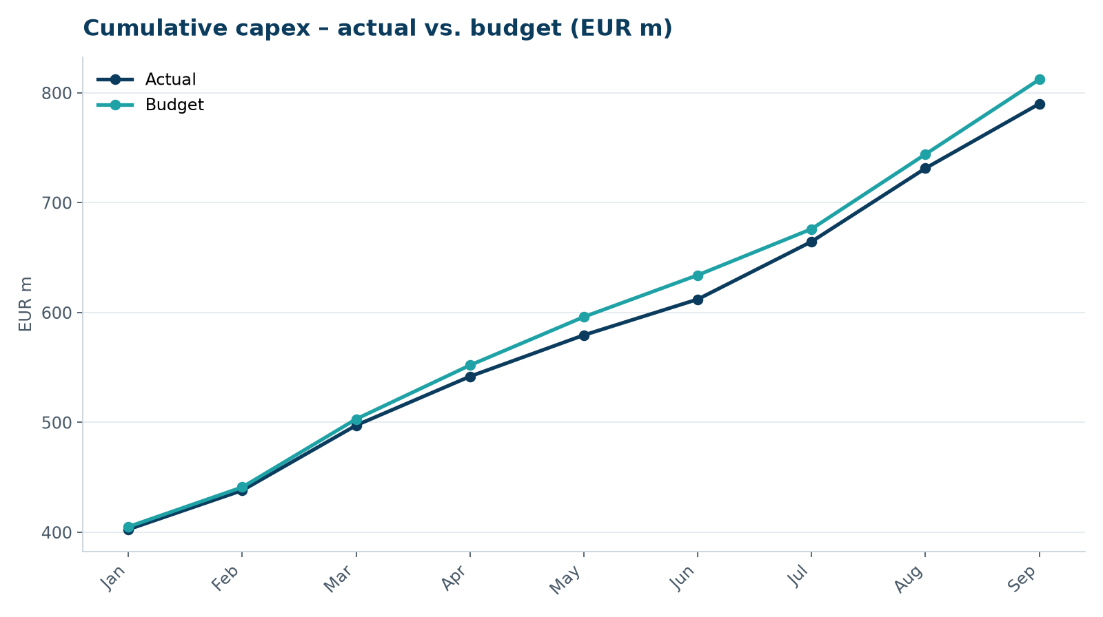
Capex development
Drawdown | Date | Amount (EUR m)
DR-06 | 15 Jul 2026 | 48.1
DR-07 | 17 Aug 2026 | 62.9
DR-08 | 15 Sep 2026 | 57.3

